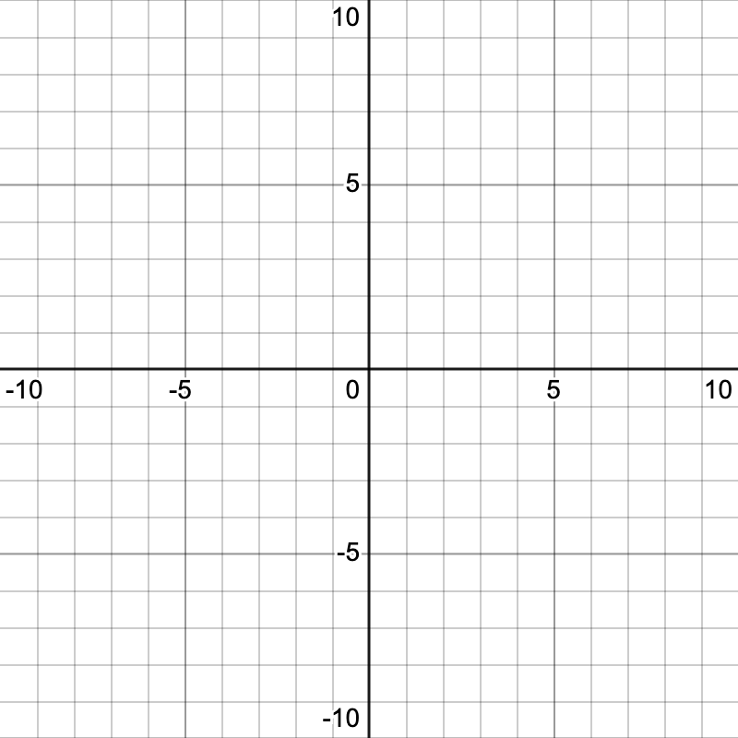
Systems of Linear Equations
- What is the solution to the system represented by the table? [Emerging]
- Solve graphically: [Developing]

$$y=x-4$$

$$y=-\frac{2}{3}x+1$$
- Solve graphically: [Proficient]

$$2x-3y-12=0$$

$$x+2y-6=0$$
x | y₁ | y₂
0 | 5 | -4
1 | 3 | -3
2 | 1 | -2
3 | -1 | -1
4 | -3 | 0
- Analyze the system to determine whether it has one solution, no solution, or infinitely many solutions: [Proficient]

$$y=2x-5$$

$$6x-3y=15$$
- Create a system so that:

    - the solution is (4, -3)
    - one line has a positive y-intercept
    - one line does not enter the second quadrant [Extending]
- Place the numbers from 1 to 9 in the boxes below so that the system has infinitely many solutions. (Each number can be used only once.) [Extending]

⬚x + ⬚y = ⬚

y = ⬚/⬚x + ⬚
solve systems of linear equations graphically | Emerging | Developing | Proficient | Extending
- Is (-2, 1) a solution to the system: [Emerging]

$$y=3x+5$$

$5x-2y=8$?
- Solve by elimination: [Emerging]

$$-5x+2y=-1$$

$$5x-4y=-13$$
- Solve by substitution: [Developing]

$$2a+3b=11$$

$$b=5a+15$$
- Solve by elimination: [Developing]

$$3x-10y=16$$

$$3x+2y=6$$
- Solve by substitution: [Proficient]

$$4x-3y=9$$

$$2x-y-5=0$$
- Solve by elimination: [Proficient]

$$3c+7d=3$$

$$5c-4d+42=0$$
- What could equations ① and ② have been? What else? How do you know? [Extending]
solve systems of linear equations algebraically | Emerging | Developing | Proficient | Extending
- One plumber charges a trip fee of $135 and an hourly rate of $105. Another plumber charges a trip fee of $195 and an hourly rate of $90. This scenario can be modelled by:

$c=135+105t$ ①

$c=195+90t$ ②

What is the meaning, in context, of (4, 555)? [Emerging]
- Four hamburgers and two hotdogs cost $42. Six hamburgers and five hotdogs cost $75. What is the price of each item? [Developing]
model and solve contextual problems involving systems of linear equations | Emerging | Developing | Proficient | Extending
- One type of cereal contains 30% fruit. Another type of cereal contains 15% fruit. How much of each should be mixed to make 600 grams of cereal that contains 20% fruit. [Extending]
- At a local garden centre, hanging baskets cost $20 and patio vegetables cost $13. A total of 120 products were sold for $2085. How many of each were sold? [Proficient]
 | Emerging | Developing | Proficient | Extending
 | Emerging | Developing | Proficient | Extending
- Below is a set of ten equations. Take a moment to notice the different forms of the equations.
Ⓐ | $$5x-2y=8$$ | Ⓒ | $-2x+4y=12$ | Ⓔ | $$4y=2x$$ | Ⓖ | $$3x+2y=0$$ | Ⓘ | $$x+y=5$$
Ⓑ | $$2x=12$$ | Ⓓ | $$y=-3$$ | Ⓕ | $$y=-\frac{1}{2}x+2$$ | Ⓗ | $$9x+6y=0$$ | Ⓙ | $$6x-4y=9$$
- Choose two equations from the set to form a system of linear equations. Solve this system using substitution.
- Choose two of the remaining equations from the set to form a system of linear equations. Solve this system using elimination.
- Choose two of the remaining equations from the set to form a system of linear equations. Solve this system using graphing.
For parts (a), (b), and (c), discuss why you chose the equations you did.
https://twominuteteachersguide.com/2021/03/01/choosing-systems-of-equations/
 | Emerging | Developing | Proficient | Extending
 | Emerging | Developing | Proficient | Extending
- Warmsnug calculated the prices of their windows according to the area of glass used and the length of frame needed.
Can you work out how Warmsnug arrived at the pricing of their windows?
Which window has been given an incorrect price?
https://nrich.maths.org/warmsnug

